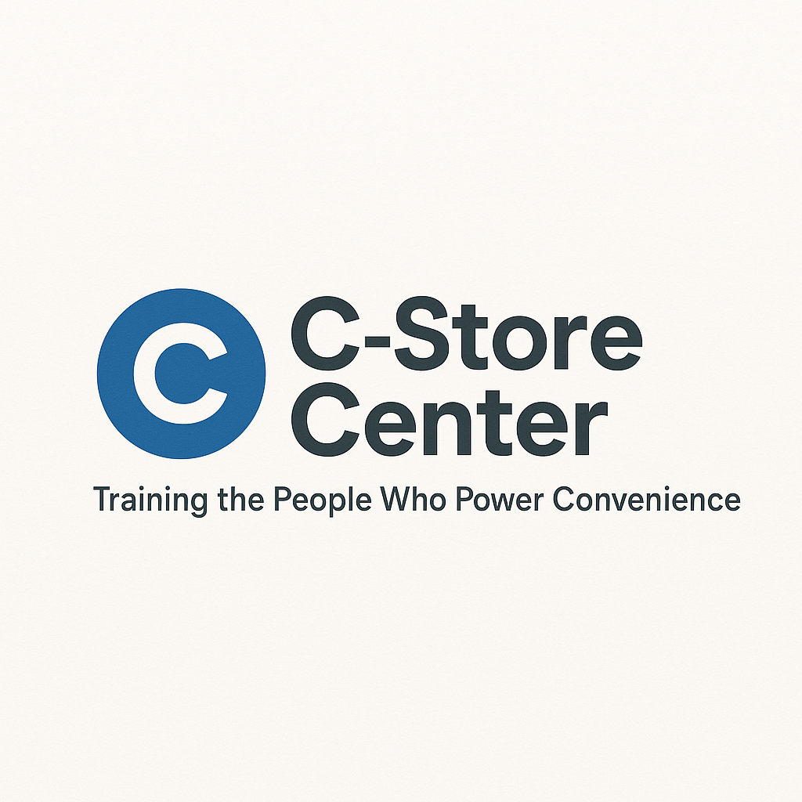
The Consolidation Survival Self-Assessment & Career Action Planner
Protect Your Career in a Changing Convenience Store Industry
1. Consolidation Survival Self-Assessment
How prepared are you for industry mergers, buyouts, or restructuring?
Check all that apply:
- ☐ I am aware of recent mergers/acquisitions in my region
- ☐ My store/company has discussed possible changes
- ☐ I have updated my resume and LinkedIn profile in the past 6 months
- ☐ I have cross-trained in at least one other store function
- ☐ I know the key metrics my employer uses to evaluate performance
- ☐ I have built relationships with district/regional leaders
- ☐ I regularly check job boards or company postings
- ☐ I know at least two people in the industry outside my current company
- ☐ I have a plan if my job/role changes suddenly
- ☐ I have saved at least one month’s living expenses
My score: ____ / 10
- 8–10: Resilient. You’re ready for anything.
- 5–7: At risk. Take action to prepare for change.
- 0–4: High risk. Start planning now!
2. Career Impact Analysis Table
Change or Trend Observed | How It Affects My Store/Role | What I Can Do About It

3. Skill Growth & Cross-Training Planner
Skill or Store Function | My Level (Beginner/Good/Expert) | Next Step to Improve
Inventory Management
Customer Service
Foodservice/Fresh Offerings
Merchandising
Technology (POS, mobile)
Safety & Compliance

4. Networking & Industry Relationship Map
Name | Company/Role | How I Know Them | Date Last Contacted

5. Career Emergency Action Plan
If I am affected by consolidation (merger, sale, etc.) I will:
- Contact: __________________________
- Update my resume/LinkedIn by: ______________________
- Review open positions at: ________________________
- Reach out to (mentor/industry friend): _______________________
- List top 3 skills I can offer a new employer:

- Set a reminder to check in on my plan on: __________________

