The City C-Store Success Kit: Urban Career & Skills Navigator

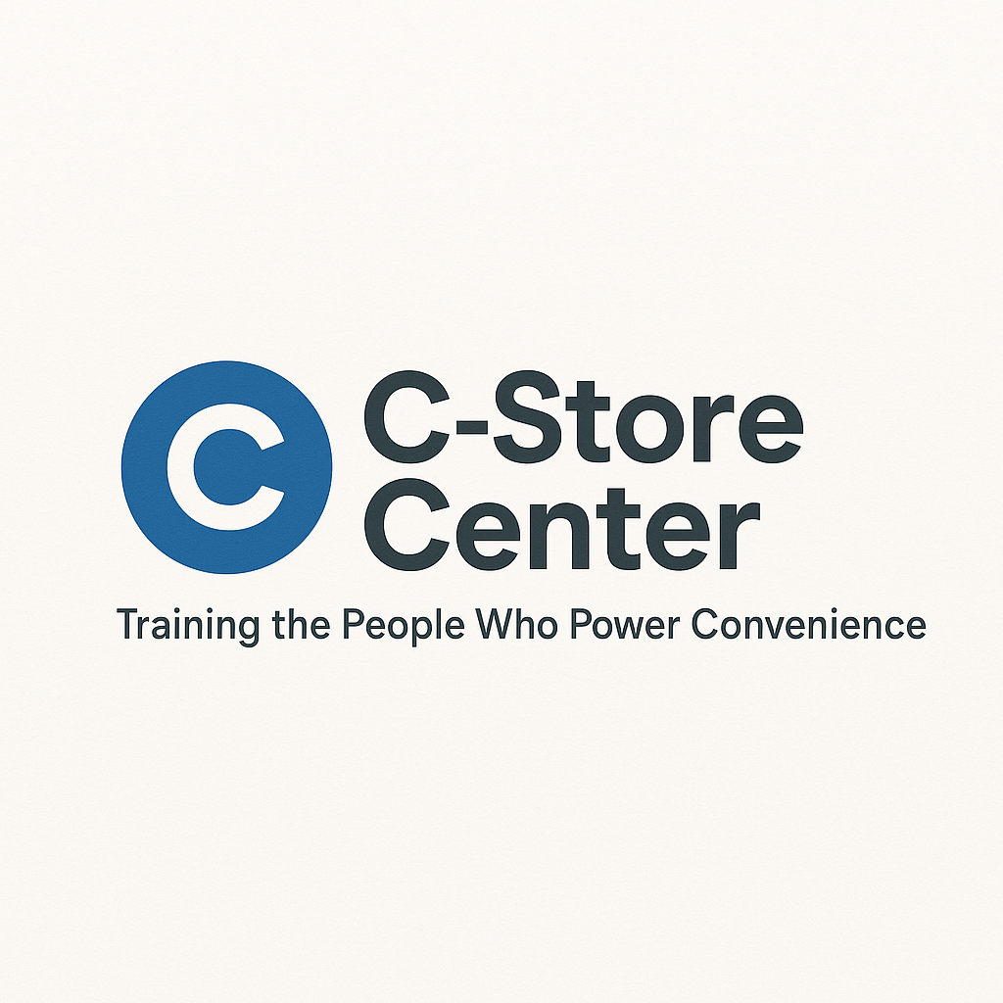
1. Urban Readiness Assessment (Quiz)
Are You Ready for Urban C-Store Success?
- Do you adapt quickly to fast-paced work environments?
- Have you worked with digital payment systems (Apple Pay, tap-to-pay)?
- Are you comfortable serving customers from diverse cultural backgrounds?
- Can you manage multiple tasks during rush hours without getting flustered?
- Do you use a smartphone or tablet for work-related tasks?
- Have you solved customer issues using translation or language tools?
- Are you comfortable promoting delivery apps or loyalty programs to customers?
- Can you optimize a small space for efficiency and sales?
- Have you taken initiative to learn about new city store concepts?
- Are you aware of career growth opportunities in urban markets?
My Urban Readiness Score: ____ / 10
8–10: Urban-ready. 5–7: Get prepared! 0–4: Time to level up!

2. City vs. Suburban Store Comparison Guide
Factor | City Store | Suburban Store
Format | Small footprint, high volume | Larger, more parking
Tech Use | High (apps, digital payments) | Moderate
Customer Diversity | Very high | Moderate
Pace | Fast, frequent rushes | Steady, more downtime
Wages/Pay | Higher (cost of living) | Moderate
Advancement | More openings, faster moves | Often less frequent

3. Tech Skills Roadmap
Skill Area | Beginner (✓) | Intermediate (✓) | Advanced (✓) | Next Steps
Mobile payments
Mobile app ordering
POS analytics
Delivery integration
Digital inventory
What will I learn next? __________________________

4. Diverse Customer Service Strategy Sheet
Scenario | What Works Best | Example Script/Action
Language barrier | Use translation app or gesture | “Can I show you where it is?”
Rush hour, diverse crowd | Greet everyone, keep line moving | “Thank you for your patience!”
Cultural holidays/events | Acknowledge, learn basic greetings | “Happy Diwali!”
Delivery app confusion | Help customer navigate the app | “Let me show you how to place an order”

5. Urban Store Layout Optimizer
Area | Problem | Solution | Date Fixed
Entrance | Crowded, blocked | Move display, clear path
Counter | Slow checkout | Add mobile payment option
Cold Vault | Hard to access | Rearrange for quick grab

6. Career Advancement Pathways in Urban Markets
Role | Needed Skills | How to Prepare | Starting Pay
Shift Lead | Multitask, tech, diverse cx | Cross-train, get POS | $
Assistant Manager | Tech, analytics, coaching | Take online course | $
Store Manager | All above, urban ops | Shadow a manager | $
District Trainer | Communication, tech lead | Help onboard staff | $

7. Salary Negotiation Strategies for City Markets
- Research pay rates for your city/role

- Show how your tech, diversity, and city skills add value

- Highlight experience with fast-paced, high-volume environments

- Prepare specific examples: “I increased basket size by…”

- Ask for transportation or cost-of-living benefits if needed

