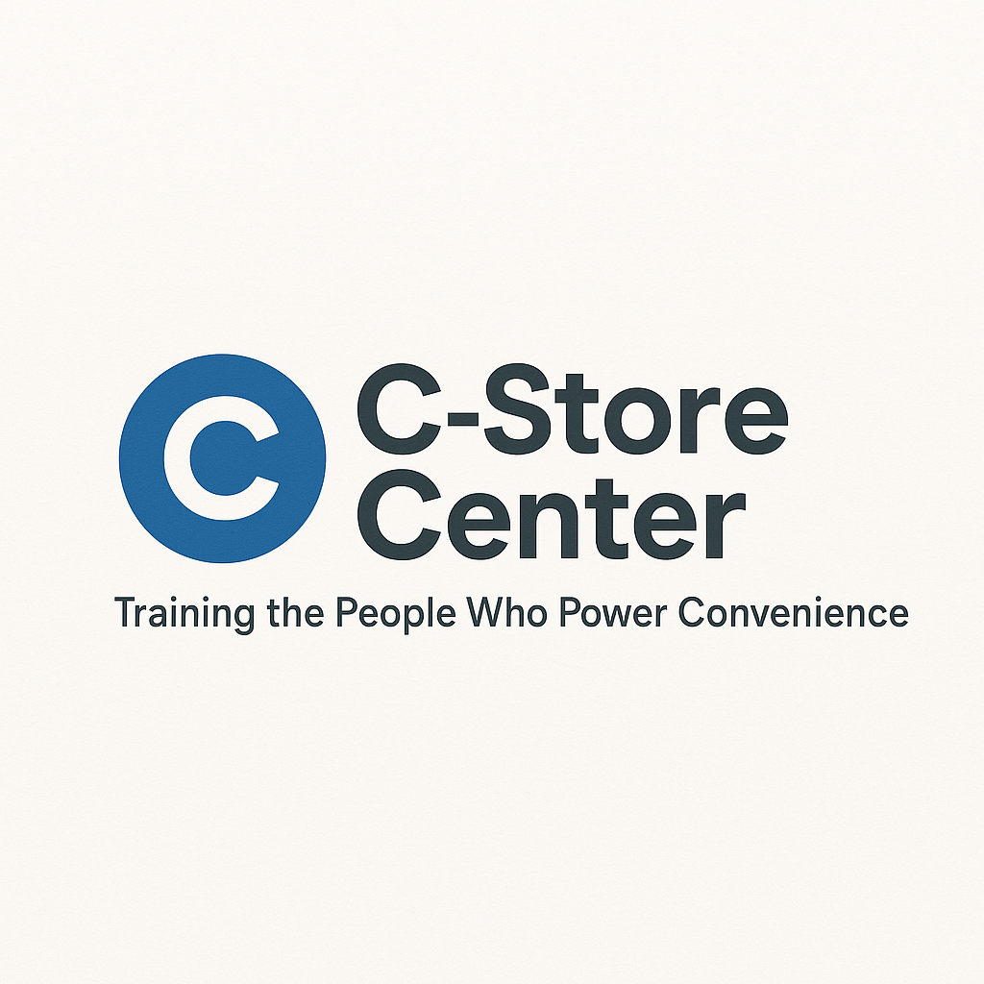
The Cashierless Career Navigator: Survive & Thrive in the Autonomous Retail Revolution

A printable toolkit for anyone wanting to future-proof their skills, with weekly action steps and assessment tools.

1. Will Your Job Survive the Cashierless Revolution? (Assessment Quiz)
Question | Yes | No
Is your current role mostly cash handling and checkout?
Have you used a self-checkout or mobile payment system at work?
Are you comfortable with mobile apps and digital kiosks?
Have you learned any new tech skills in the past year?
Are you aware of the automation plans at your company?
Have you received training on remote monitoring or tech support?
Can you troubleshoot basic device errors (scanner, POS, app)?
Do you know how to analyze sales or inventory data digitally?

Your Score: ____ / 8
- 7–8: Automation-Proof!
- 5–6: At Risk—Upskill Now
- 0–4: Start Planning Your Transition

2. Transferable Skills for Autonomous Store Operations
Traditional C-Store Task | Autonomous Store Skill Equivalent
Cash handling | Mobile/app payment support, troubleshooting
Stocking shelves | Remote monitoring, sensor checks
Customer greeting | App support, remote customer engagement
Cleaning/maintenance | Tech maintenance, error logging
Reporting to manager | Data analytics, dashboard reporting

3. Personalized Career Transition Plan
Step 1: Assess Your Role
- List your daily tasks:

- Circle which ones could be automated in the next 2 years
Step 2: Identify Skills to Build
- What tech, remote, or troubleshooting skills will you need?

- Who can you learn from or ask for help?

Step 3: Set Your Weekly Goal
- This week, I will:
  - Watch a video about cashierless stores
  - Ask my manager about tech training
  - Try a new app or kiosk at work

4. Autonomous Store Technology Timeline
Year | New Tech Arrives | Impact on Roles | Skill to Build Next
2025 | Widespread self-checkout | Fewer cashier hours | Customer tech support
2026 | Remote inventory sensors | Automated stock checks | Troubleshooting, data basics
2027 | AI-powered loss prevention | Less security staff needed | Tech monitoring, analytics
2028 | App-based promotions/loyalty | Personalized marketing | Data entry, customer support

5. Remote Monitoring & Support Skills Checklist
- Comfortable using store apps or dashboards
- Able to monitor sales or inventory in real time
- Can troubleshoot scanner/kiosk errors
- Can answer customer tech questions
- Know how to document and report issues to HQ
- Have taken at least one online tech/AI course

6. Interview & Salary Negotiation Prep for Autonomous Roles
Interview Prep:
- “Tell us about a time you solved a problem with technology at work.”
- “How would you help a coworker learn a new system?”
- “What steps would you take if a remote sensor stops reporting data?”
Negotiation Tips:
- Highlight any tech skills, certifications, or troubleshooting experience
- Ask about pay for new hybrid or remote monitoring positions
- Discuss opportunities for ongoing tech/AI training
Notes:

7. Your Weekly Automation Survival Plan
Week | Focus Area | Goal/Action | Complete? (✓)
1 | Automation Impact | Take the quiz, review daily tasks
2 | Tech Upskill | Watch an AI/automation tutorial
3 | Remote Monitoring | Practice dashboard or inventory tool
4 | Career Positioning | Update resume, prep for interviews

