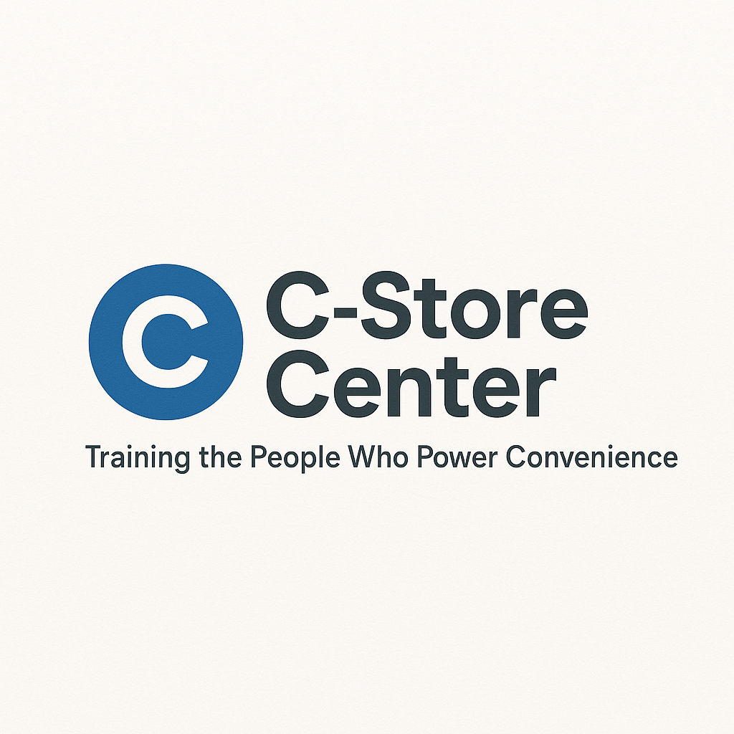
The AI-Proof Career Kit: Master the Technology Changing
C-Stores Forever
Future-Proof Your Job, Upskill with Confidence, and
Become the Employee Every Store Wants

1. AI Readiness Assessment (Quiz)
Will AI Replace Your Job or Make You More Valuable?
(Check Yes or No for each statement)
# | Question | Yes | No
1 | I know which AI tools are coming to my store/role
2 | I regularly use digital/tech tools at work
3 | I am confident in learning new technology quickly
4 | I have experience working alongside automated systems (self-checkout, inventory robots)
5 | I follow news about AI changes in the c-store industry
6 | I have taken online courses or watched tutorials about AI or digital skills
7 | I can explain at least two ways AI is changing customer service
8 | I have ideas for how to use AI to make my job easier
My AI Readiness Score: ____ / 8
- 7–8: AI-Ready — you’re ahead of the curve!
- 4–6: On Your Way — upskill now to stay ahead.
- 0–3: Don’t Wait — start building tech confidence!

2. Personalized AI Adaptation Strategy
What’s Your Next Step?
- If you scored 0–3:
  - Watch one AI basics video this week
  - Practice using a new tech tool at work/home
  - Ask a tech-savvy friend or co-worker to show you something new
- If you scored 4–6:
  - Sign up for an online course about AI in retail
  - Request to help with a tech-related task at work
  - Research which AI tools are coming to your company
- If you scored 7–8:
  - Volunteer to train others on AI basics
  - Create a “How to work with AI” tip sheet for your team
  - Join industry forums or groups to stay updated

3. AI Technology Timeline Tracker
Year | Tech Arriving in Stores | How It Might Affect You | What to Learn/Do Next
2025 | Self-checkout upgrades, mobile apps | Fewer cashier tasks, more tech needs | Customer help, app navigation
2026 | Inventory robots, smart shelf sensors | Stocking/ordering automated | Data reading, inventory basics
2027 | AI-driven customer offers/promos | More targeted sales, data work | Customer data privacy, suggest promos
2028 | Security AI (loss prevention) | New monitoring/alerts | AI alert response, camera review

4. Skill Development Roadmap
Skill Area | Current Level | How to Improve | Target Date
Digital Literacy |  | Take free online tech tutorials
Customer Experience |  | Practice AI-enhanced greetings
Data Entry/Analysis |  | Use a store reporting dashboard
Inventory Tech |  | Help test new scanning systems
Collaboration |  | Share tips with team

5. “Human + AI” Collaboration Playbook
For Cashiers:
- Help customers use self-checkout; answer questions
- Report glitches or problems to management promptly
For Stockers:
- Learn how inventory robots scan shelves
- Double-check and report any stock discrepancies

For Managers:
- Track team adoption of new AI systems
- Give feedback to upper management about tech rollouts
For All:
- Suggest process improvements when you spot a tech challenge
- Ask for training — don’t wait to be told

6. AI Interview Prep Guide
- “Tell me about a time you learned a new tech system at work.”
- “How would you help a less tech-savvy co-worker adapt to AI tools?”
- “What’s one way you think AI will make your role more valuable?”

7. Salary Negotiation & Career Advancement Guide
- Show how your AI skills add value:
“I trained the team on our new self-checkout system, which sped up lines by 15%.”
- Negotiate for career opportunities:
“With my experience helping test inventory robots, I’d like to take on a lead or trainer role.”

8. Career Advancement Pathways in AI-Integrated Stores
Role | AI Skill Needed | How to Get Ready
Tech Ambassador | Customer support, app help | Train on customer tech tools
Inventory Lead | Robot scanning, data review | Learn inventory AI basics
Store Trainer | Teaching, system troubleshooting | Run peer learning sessions
Shift Leader | Overseeing tech, process change | Assist in pilot programs

