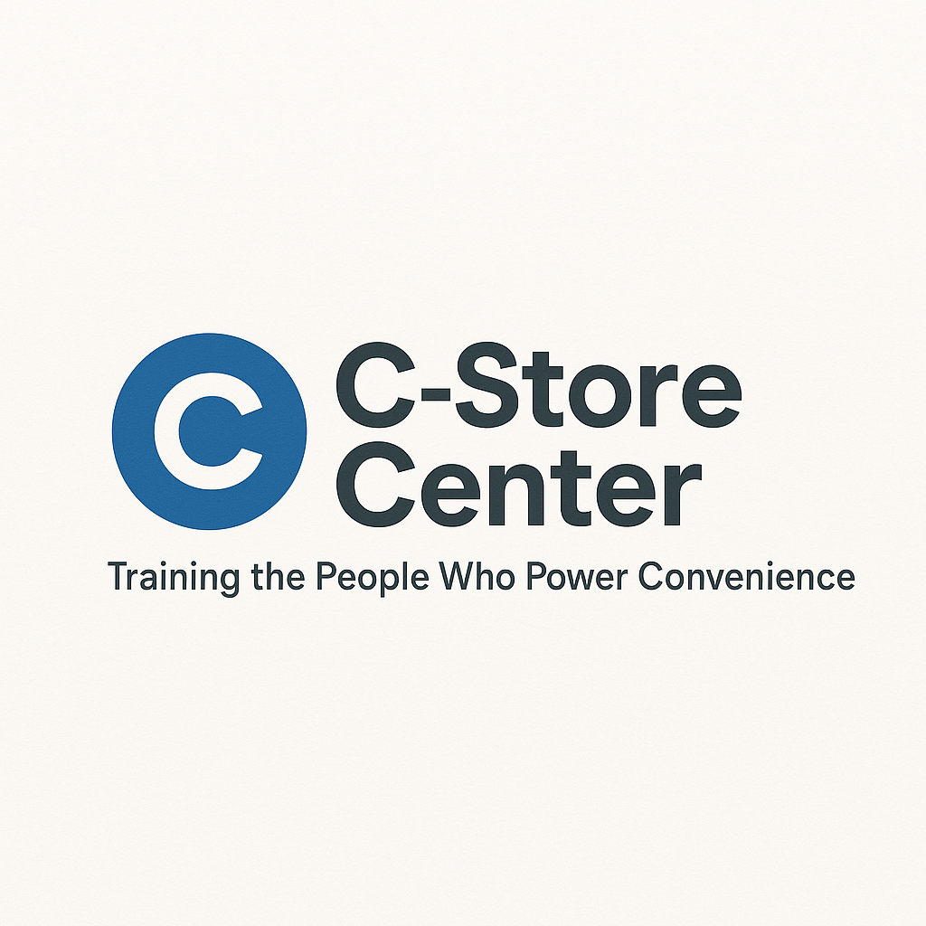
The 7-Second Store Transformation Kit
Turn Every Customer Entrance Into a Sales Opportunity

1. Entrance Impact Assessment (Quiz)
Is Your Store’s First Impression Driving Customers Away?
(Check “Yes” or “No” for each statement below)
# | Question | Yes | No
1 | The entrance area is free of clutter and debris
2 | Mats or floors are clean and dry
3 | Lighting at the front is bright and inviting
4 | Displays near the entrance are well-organized and not blocking traffic
5 | Store hours and signage are easy to read
6 | The scent near the entrance is pleasant or neutral
7 | Customers are greeted within 7 seconds
8 | Entrance is free of loitering or intimidating behavior
9 | Promotional signs at the entrance are up-to-date
10 | Team members look up and smile when a customer enters
Your Score: ____ / 10
(8–10 = Excellent, 6–7 = Needs Improvement, 5 or less = High Priority!)
Top 3 things to fix now:

2. Hour-by-Hour Entrance Maintenance Checklist
Shift | Task | Completed? (✓)
AM | Sweep entrance walkway
AM | Shake/clean floor mats
AM | Wipe down doors and handles
Midday | Re-check floor/mats for dirt/wetness
Midday | Tidy displays near entrance
Midday | Confirm signs/promos are current
PM | Sweep, mop, or spot-clean as needed
PM | Remove clutter or empty boxes
Close | Inspect for lost items or trash
Close | Turn off/lock signage as needed

3. Customer Greeting Script Bank
Use these scripts (adapt or add your own):
- For regulars:
“Hey, good to see you again! Welcome back.”
- For new customers:
“Welcome in! If you need help finding anything, just let me know.”
- During busy rush:
“Thanks for waiting—welcome in!”
- When it’s slow:
“Hi there! How’s your day going?”
- When you notice hesitation:
“Is there anything I can help you with right away?”
- After a bad weather day:
“Glad you made it in out of the rain—anything I can get started for you?”
4. Entrance Display & Flow Optimizer
Sketch or plan your entrance here:
Element | Current Setup | Needs Improvement? | Notes/Plan
Display Table
Promo Signage
Walk Path Clear
Seasonal Decor
Lighting
Flow Checklist:
- ☐ Path from door to sales floor is open
- ☐ Displays do NOT block the main walkway
- ☐ Promotional offer is easily visible
- ☐ Welcome mat or rug is clean and straight
- ☐ No “invisible wall” of clutter or signage

5. Weather & Seasonal Adaptation Planner
Weather/Season | Entrance Issue | Quick Fix / Adjustment | Date Done
Rain | Wet floors/mats | Add extra mats, dry mop, “Caution” sign
Summer heat | Blinding sunlight at door | Angle displays, check for shade, tint
Holidays | Decor/crowded displays | Use wall space, avoid blocking door
Cold/windy | Door drafts | Adjust mat/door stop, seal gaps
Spring (pollen) | Dust/pollen on mats | Sweep and shake out mats often

6. “First 7 Seconds” Observation Log
Date | Employee | Customer Reaction / Notes | What Worked? | Next Shift Idea
Observe a few customers per shift and discuss as a team what can be improved!

