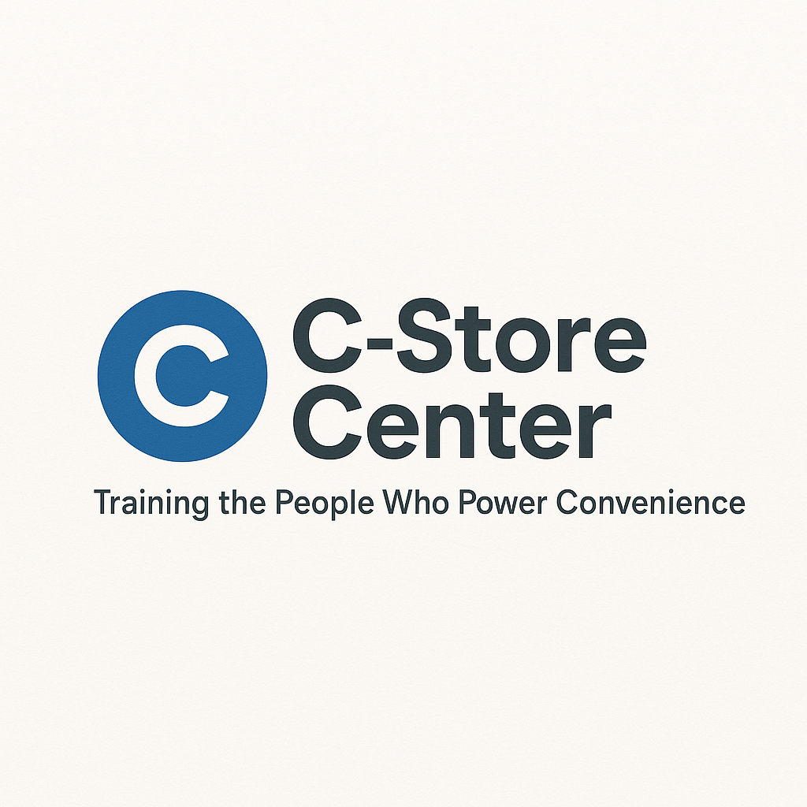
Positive Store Culture Starter Kit
A Practical Resource for Building a Winning Workplace, One Shift at a Time

1. Store Culture Self-Assessment
How Welcoming Is My Store? (Check all that apply):
- ☐ Customers are greeted within 10 seconds
- ☐ Coworkers treat each other with respect
- ☐ Everyone helps clean shared spaces
- ☐ I feel safe and supported at work
- ☐ Mistakes are used as learning moments
- ☐ Compliments are shared often
- ☐ Team members step in to help when needed
- ☐ Management listens to staff ideas
- ☐ Employees are recognized for good work
- ☐ New employees are welcomed by everyone
My Score: ____/10
What’s one thing I can do to make my store more welcoming today?

2. Daily Actions for Better Culture
Quick Checklist:
- ☐ Greet every coworker by name
- ☐ Offer to help when someone looks busy
- ☐ Keep common areas clean
- ☐ Compliment a teammate on a job well done
- ☐ Smile at every customer
- ☐ Ask for feedback on my work
- ☐ Share a positive story from today
- ☐ Thank a coworker for something specific
Small Actions Log:
Date | Positive Action I Took Today

3. Recognition & Appreciation Log
Peer Recognition Tracker:
Date | Who Recognized | Who Was Recognized | Reason / Compliment
Ideas for Celebrating Small Wins as a Team:
- Group “shout-out” at shift change
- Share a favorite snack or treat
- Team photo for the breakroom wall
- “Star of the Week” board
- High-five chain (pass it around after good service)

4. Communication Skills Builder
Scripts for Common Situations:
- Welcoming a new team member:
“Hi, I’m [Your Name]. Glad to have you with us! If you need anything, just ask.”
- Giving positive feedback:
“I noticed you [describe action], and it made a real difference—thank you!”
- Addressing a concern:
“Hey, I wanted to check in about [situation]. Can we talk about how to handle it better?”
- Resolving a conflict:
“I know we had a tough moment earlier. Let’s figure out how to work together going forward.”
- Encouraging input:
“What’s one idea you have that could make our store better?”
How to Talk So Your Team Listens:
- Be clear and specific
- Focus on actions, not personality
- Ask questions—then listen
- Stay calm, even if you’re upset
- Repeat back what you heard to show you understand

5. Support System Worksheet
Employee Buddy/Support Partner Template:
New Employee | Buddy / Support Partner | First Week Focus | Notes

6. Conflict Resolution Roadmap
Step | What To Do | Notes
1 | Name the issue (“We had a problem with…”)
2 | Listen to each person’s side
3 | Brainstorm possible solutions together
4 | Agree on a solution and follow up (“Let’s try this…”)

7. Sustaining the Change
Monthly Improvement Tracker:
Month | What’s Better This Month? | What’s Next to Improve?
Commitment Pledge:
“This month, I will help build a positive store culture by:

Signed: ________________________ Date: _______________”

