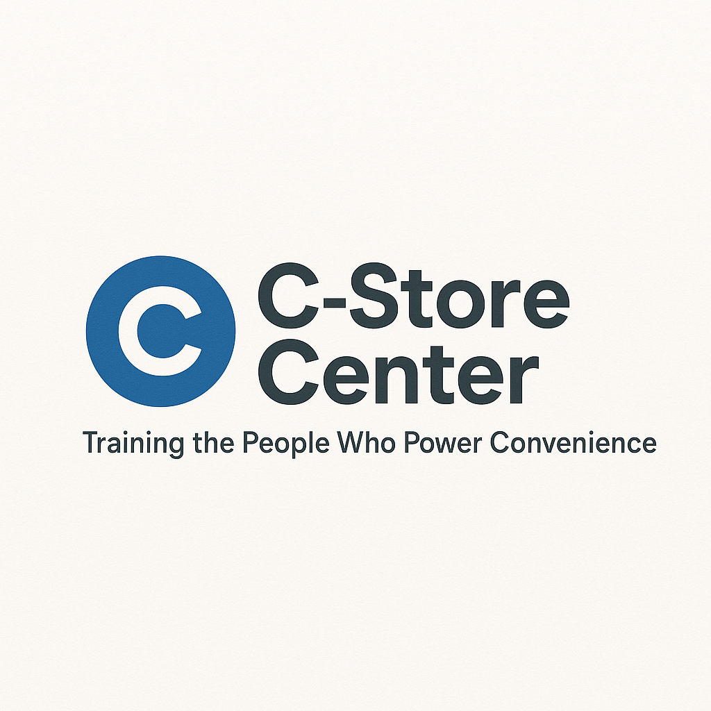
C-Store Industry Insider Map: Career Opportunity Assessment Toolkit
Unlock Your Next Career Move in a 152,255-Store Industry

1. Career Opportunity Assessment Quiz
Where Do You Fit in 152,255 Stores?
(Check all that apply)
- ☐ I know how many convenience stores are in my state
- ☐ I work for a chain or independent store (circle one)
- ☐ I understand the main differences in career paths at single-store vs. chain operators
- ☐ I know which states have the most stores per capita
- ☐ I am open to relocating for better career opportunities
- ☐ I know the average pay for my role in different regions
- ☐ I track industry trends (fuel, EV, mergers) at least monthly
- ☐ I have researched stores opening/closing in my area
- ☐ I have a career goal for the next 12 months
- ☐ I know someone who advanced by moving to a different market

My Score: ____ / 10
- 8–10: Industry Navigator (prime for growth!)
- 5–7: Opportunity Aware (needs more info!)
- 0–4: Missing out! Time to get informed.

2. State/Region Opportunity Map (Quick Reference Table)
State/Region | # of Stores | Market Trend (Growing, Flat, Declining) | Best Roles to Target | Notes
Texas | 16,400+ | Growing | Assistant Mgr, DMs | High turnover
Florida | 10,000+ | Growing | Foodservice, Mgr | Tourism heavy
California | 12,000+ | Flat | All roles | High cost
...

3. Chain vs. Independent Career Path Analyzer
Factor | Chain Store Advantage | Independent Store Advantage
Promotion Speed | Faster, clear ladder | Flexible, based on trust
Pay Potential | Higher at upper level | More negotiation possible
Skill Growth | Training, big network | Wear many hats, learn fast
Relocation Required? | Often | Rare
Job Security | Stable if large chain | Linked to owner's health
...

4. Industry Trend Tracker
Trend (e.g. Fuel, EV, Delivery) | Impact on Store Careers | What Should You Do?
Fuel volume flat, EV up | More tech roles coming | Upskill in tech/sales
Mergers & consolidation rising | More big chains | Prepare for transitions
Delivery partnerships increasing | New driver/gig jobs | Cross-train for delivery

5. Career Advancement Planner
Goal for 2024 | Best State/Region | Store Type | Steps to Take This Quarter

6. Personalized Opportunity Action Plan
This month I will:
- Research store openings/closings in: _________________________
- Connect with a c-store pro in a different state/chain: __________________
- Update my resume/LinkedIn with these 3 new skills:

- Set up an alert for industry market news

